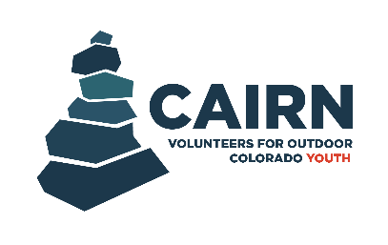

VOC Cairn Program - Mentor Application

Applicant Information
Name (First & Last)*:
Preferred pronouns (optional):
Email Address*:
Phone Number*:
City*:
State*:
Zip Code*:
Employment Information
Current Employer*:
Position*:
Education History
Highest Level of Education Achieved*: Dropdown with “Some high school, Highschool diploma, Some college, Degree”
Degree:
Short Answer Questions
Why do you want to volunteer with VOC as a Cairn Mentor?*:

What type of experience do you have working with or leading youth?*:

Why do you think it’s important to care for our natural environment?*

Additional Information
Please list any current certifications that you have that are related to working with youth:
Example: CPR, First Aid, etc.
No current certifications are required to serve as a mentor in the Cairn Program.

Please list your volunteer experience, if any:

How did you hear about the Cairn Program?*

References
Reference #1
Name*:
Relationship to Reference*:
Years Known*:
Preferred Contact Information*:

Reference #2
Name*:
Relationship to Reference*:
Years Known*:
Preferred Contact Information*:

Reference #3
Name*:
Relationship to Reference*:
Years Known*:
Preferred Contact Information*:

